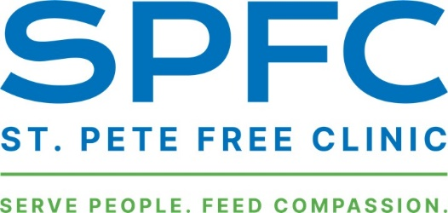
Notice of Privacy Practices
THIS NOTICE DESCRIBES HOW MEDICAL INFORMATION ABOUT YOU MAY BE USED AND DISCLOSED AND HOW YOU CAN GET ACCESS TO THIS INFORMATION. PLEASE REVIEW IT CAREFULLY.

At the St. Pete Free Clinic Health Center, we treat your health information as personal. We keep records of the care and services that you receive at our facilities. We are committed to keeping your health information private, and we are required by law to respect your confidentiality. This Notice describes the privacy practices of the St. Pete Free Clinic. This Notice applies to all of the health information that identifies you and the care you receive at our facilities. Your health information may consist of paper, digital or electronic records but could also include photographs, videos and other electronic transmissions or recordings that are created during your care and treatment. Federal and state laws require the St. Pete Free Clinic Health Center to protect your health information and federal law requires us to describe to you how we handle that information. When federal and state privacy laws are different and conflict, and the state law is more protective of your information or provides you with greater access to your information, then we will follow the state laws of Florida.
Full Policy in English
Política Completa en Español

HIPAA Compliance Officer
Rob Thomas, DrPH, MBA, CWP
rthomas@thespfc.org - 727-327-0333

